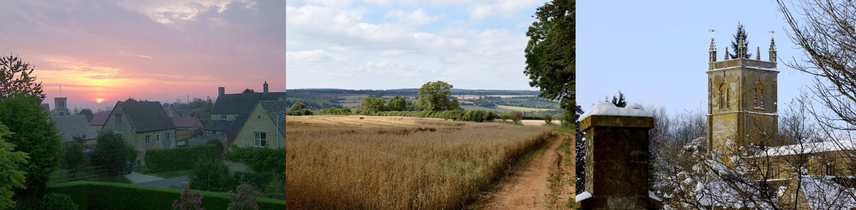

Blockley Parish Council

Annual Parish Meeting
Thursday 18th May 2023
at 8:00pm in Village Hall, Paxford
All who are resident in the Parish are welcome to attend.
AGENDA

- Welcome and Apologies by Chair of Blockley Parish Council
- Approval of the minutes of Annual Parish Meeting on 29th May 2022
- District Councillor’s Report
- County Councillor’s Report
- Parish Council annual report Cllr Clare Turner
- Reports by Lead Councillors:
  - Financial Report by Cllr Jon Bryan
  - Personnel Committee – Cllr Paul Baines
  - Planning – Cllr Clare Turner
  - Youth & recreation – Cllr Kirsty Derson
  - Burials – Cllr Jon Bryan
  - Environmental Sustainability – Cllr Clare Turner
- Local society updates (guest speakers from all parish societies are invited to provide an update)
- Opportunity for Parishioners to ask questions/make comments

