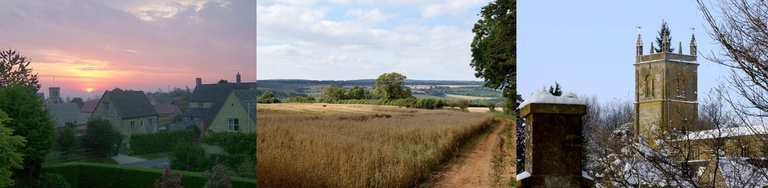

Blockley Parish Council

Annual Parish Meeting

thursday 18th June

Minutes

PRESENT: Cllrs – J Bryan (presiding), C Turner (Vice Chair & District Cllr), P Baines, K Derson, E Thorneycroft, S Neill, T Bradley, A Fowlie
Members of the public: 3
Apologies for absence accepted from: Cllr S Waltham, County Cllr Lynden Stowe, Rec Dana Delap
- Welcome and Apologies by Chair of Blockley Parish Council
Apologies received from Rev Dana Delap, Sally Waltham, C Cllr Stowe
- Approval of the minutes of Annual Parish Meeting on 29th May 2022 JB proposed to approve with amendment to point 8, seconded CT, abstentions AF, SN, agreed by majority.
- District Councillor’s Report – Chair congratulated C. Turner and welcomed her as our new District Cllr new. No report on past year provided by outgoing D Cllr. Action: CT & Clerk to meet and identify collaborative working opportunities with neighbouring Parish & Town councils.
- County Councillor’s Report – None provided
- Parish Council Annual report from outgoing Chair, Cllr Clare Turner: It has been a busy year and with only 6 of the 11 councillor roles filled council has worked hard to keep services to the parish on track. Chair acknowledged the work of all the Cllrs and thanked them We now have 9 councillors and hope to co-opt a further 2 to bring us up to full complement of 11. Chair’s report included Planning, Grounds Contract, Youth Club, Communications, Residents’ enquiries, Grants and Community involvement. She outlined challenges and projects for the year ahead : Full copy available on website. Councillors thank C Turner for her hard work as Chair.
- Reports by Lead Councillors:
6.1 Finance Report – J Bryan. Special thanks recorded to departing B Cowles, S Longbottom, Ray Mayo. J Bryan presented full report of financial year: Full copy available on website
6.2 Personnel Committee – P Baines recorded two new recruits to BPC; Parish clerk & RFO, N Holt who joined at the end of May 2022, and Maintenance officer, Steve Woods who joined August 2022: Full copy available on website.
6.3 Planning – C Turner gave update as there was no lead councillor for past year. We have had several breaches of planning, some of which are ongoing. We now have a lead councillor S Neill for this year and along with C Turner’s role as District Councillor we hope to have closer liaison with CDC Planning department going forwards.
6.4 Youth & Recreation report – K Derson. Stretch & Balance classes for which BPC fund the hall hire continue to receive very positive feedback. Youth Club numbers remain high. Committee met with leader & children; BPC are looking into ways to increase community engagement – youth council idea. ROSPA report has given a few things to be looked at in the play areas, to be discussed at June BPC meeting. Summer camps in 2022 were successful, thanks due to E Thorneycroft for organising.
6.5 Burials – J Bryan. It has been a year of maintenance, entrances, adequate display of policies, bins area. He and Clerk conducted Tilt test in cemetery and will present report at June meeting: Full report on website.
6.6 Environmental Sustainability – C Turner. There have been reduced activities this year due to pressure on diaries. Full report available on website
- Local society updates (guest speakers from all parish societies were invited to provide an update)
WI - Sheila Weir reported that the WI has disbanded due to increase in subs. Blockley Women Connect has been created and they are planning a programme of events with lots of interests. They will continue to support charities.
Blockley Toddler Group - Marion Janner reported a successful year with lots more volunteers. They would love to look at permanent fencing for outside play with a gate big enough for a mower to enable outside play in good weather. T Bradley mentioned insurance & ownership of stretch of grass as issues to overcome. MJ & TB will discuss further.
Dogley – Marion Janner reported an increase in followers – good source of information for Dog lovers, animal lovers, visitors to the village. Stall at May fair was very popular.
St George’s Hall – T Bradley updated no change to hire charges – frozen until renovations complete.
Friend of School – C Turner thanked BPC for support of Gingerbread trail – FOS support school, food bank monthly collection at school. They are planning to re-visit Playdate in the Park which was previously successful.
Allotments Association – C Turner reported it had been a productive year; they won1st prize at Moreton Show and have a small waiting list
Church in Blockley plans to have an open day to show plans for church.
Speedwatch Group – may have approval to get a camera. JB queried need for an ANPR policy for the parish? Action: Clerk to check
- Opportunity for Parishioners to ask questions/make comments - None.

Meeting closed 9pm

Approved by Blockley Parish Council:

Signed: ………………………………………………….. Print: ………………………………………….
Date: ………………………….

