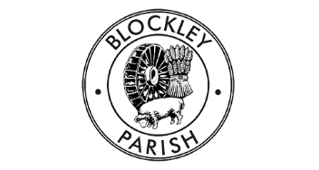

There are 5 vacancies on the Parish Council, so if you would like to contribute to your community please get in touch. Our councillors work hard to achieve the best for the parish and are committed to ensuring fair representation. We are particularly interested in hearing from residents in Draycott and Paxford which currently have no councillors. The council meet 10 times/year (no meetings August & December). If you would like to know more please email parishclerk@blockley.org.uk

