Blockley Parish Council
BPC MEETING 16th May 2024, St George’s Hall, Blockley
Minutes
Present: J Bryan, C Turner, E Thorneycroft, C Leech, C MacKinnon-Little, J Pargeter
Apologies: T Bradley
Not present: L Stowe
Meeting opened:19.05

- Election of Chair & Vice-Chair of the Parish Council. J Bryan was voted as Chair unanimously, C Turner was voted as Vice-Chair unanimously
- Welcome and apologies for absence – Cllr Bradley.
- Declarations of Interest and Dispensations for items on the agenda - Councillors must declare it if they have an interest in any matter before the council either at the start of the meeting or prior to commencement of discussion of the topic in question. CT declared interest of Environmental planning advised her partner is consultant in this area.
- Appointment of Lead Councillors: Burial Grounds - Cllr Leech unanimous, Finance – Cllr Bryan unanimous, Youth - Cllr Leech unanimous, Environmental Sustainability - Cllr Turner, Personnel - Cllr MacKinnon-Little, Planning - Cllr Pargeter.
- Appointment of committees/working groups: Environmental Sustainability Working Group – Cllr MacKinnon- Little, Cllr Pargeter, Cllr Leech. Youth Working Group – Cllr Turner, Cllr Thorneycroft. Planning Working Group – Cllr Mackinnon-Little, Cllr Turner (environmental input). Personnel Committee – Cllr Turner, Cllr Leech, Cllr Pargeter, Cllr Thorneycroft.
- Appointment of councillors to sit on the St George’s Hall management committee in addition to Cllr Bradley - Cllr MacKinnon-Little, Cllr Thorneycroft, Cllr Turner, Cllr Bryan.
- Appoint councillor to participate in the OPCC advocacy scheme - Cllr Turner.
- Public Participation - None
- Approval of the minutes of the Extraordinary Parish Council Meeting of 10th May 2024 approved, and Parish Council Meeting of 18th April 2024. approved unanimously.
  - Matters arising see appendix 1.
- Planning: review of current planning applications as shared prior to meeting
  - To consider & approve design of Aston Magna Bus shelter proposal. Agree next steps. Planning Working group to take this on.
- Finance: – Cllr Bryan
  - Finance Report for 13.04.24 – 10.05.24 including bank reconciliation for April 2024 & detailing all accounts held by the council as circulated and shared prior to meeting. Approved unanimously
  - Transactions for period 13.04.24 – 10.05.24 as shared prior to meeting. Approved unanimously.
  - End of year position including Bank reconciliation as shared prior to meeting. Agreed unanimously.
  - To appoint 3rd Bank signatory for authorisation of online payments. Cllr Thorneycroft. Agreed unanimously.
  - To approve the continuation of the clerk’s registration in the NEST pension scheme. Agreed unanimously.
  - To approve the process of BACS payments as stated at Financial Regulation 24.9. Agreed unanimously.
  - To approve the direct debit payments: Grundon, NEST pension, Unity Trust Bank Service Charges. Agreed unanimously.
  - To approve Clerk’s membership of SLCC £229 annually. Agreed unanimously

- Clerk’s Highlights – as shared prior to meeting.

Bank:
Current Account Balance: £134,025.40
Instant Access Account Balance: £118,645.62
Total £252,851.02
Adjusted Bank Balance considering unpresented payments and receipts Total: £251,685.09
The bank was last reconciled to the 30th April 2024
Income:
£89,224 CDC Precept
£769.41 CDC CiL
£350 Allen & Son Burial fees

Expenditure:
View Transaction report (as minuted) for all transactions over reported period. Of Note:
Annual subscriptions: £673.92 for Scribe (accounting) £100 ICCM (cemetery/churchyard/ institute)
Grant Payment: £360 LVH Souper Mondays
BSSC QTRLY payment, MUGA & Hire: £180 + £420
End of year finances:
Refer to supplementary reports for variances to 22-23 FY and 23-24 budget. Considerable under expenditure due to reduced maintenance requirements vs recent years freeing up capital for reserves transfer to be considered for June ’24 motion in contribution to outstanding CAPEX requirements with parish Walls, Monuments & cemetery land acquisition.
Caution for 24-25 considering pending staffing review, grants applications & ROSPA inspection follow up. Unspent ad-hoc youth and rec and events budget, some last-minute vendor cancellation but small pool of providers to step in. Potential to book up further in advance/diversify offering.
Adjusted bank balance £166,950.16 as of 31st March. (Reconciliation approved April ’24)
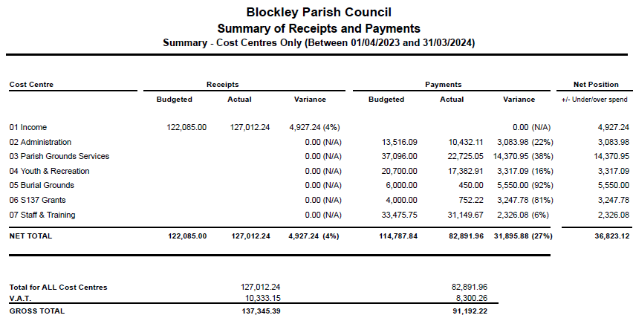

BPC transactions 13.04.24 - 10.05.24
 |  | Closing Balance | 131854.6
03May2024 | B/P to: ROSPA Play Safety |  | -492
03May2024 | B/P to: Mr Steven Woods |  | -21.6
03May2024 | B/P to: Cloudy Group Plc |  | -129.83
03May2024 | B/P to: Inspire to Aspire |  | -1033.5
03May2024 | B/P to: Starboard Systems |  | -673.92
24Apr2024 | ALLEN & SON LIMITE |  | 350
24Apr2024 | B/P to: HMRC Cumbernauld |  | -233.55
24Apr2024 | B/P to: ICCM |  | -100
24Apr2024 | B/P to: Sue Salmon |  | -360
24Apr2024 | B/P to: St Georges Hall |  | -60
24Apr2024 | B/P to: BT |  | -522.48
24Apr2024 | B/P to: R A Dunn |  | -45
24Apr2024 | B/P to: Paxford VH |  | -28
23Apr2024 | Direct Debit (GRUNDON WASTE MANA) |  | -62.26
18Apr2024 | Direct Debit (NEST) |  | -95.37
18Apr2024 | COTSWOLD DC -AP |  | 89224
18Apr2024 | COTSWOLD DC -AP |  | 769.41
16Apr2024 | B/P to: Mr Steven Woods |  | -704.16
16Apr2024 | B/P to: Mrs NC Scott |  | -1594.16
16Apr2024 | B/P to: BL sport social cb |  | -420
16Apr2024 | B/P to: C Scobie |  | -38
16Apr2024 | B/P to: BlockleySports Ltd |  | -180
16Apr2024 | Direct Debit (LLOYDS BANK PLC) |  | -3
 |  | Opening Balance | 48304.97

Meeting Closed: 19.54

Date of Next Meeting: 7pm Thursday 20th June 2023, Draycott Mission

Approved by Blockley Parish Council:

Signed………………………………………….

Print…………………………………………….

Date…………………………………………….

